|  |  |  |
| --- | --- | --- |
|  | **K. J. Somaiya Institute of Engineering and Information Technology, Sion, Mumbai**  *Accredited with ‘A’ Grade by NAAC (3.21 CGPA)*  *Three Programs* *Accredited by NBA*  *Best College Award by University of Mumbai (Urban Region), ISTE (MH), CSI (Mumbai)* | Description: G:\Kavita\Self Appraisal\trust_logo.jpg |

**DEPARTMENT OF INFORMATION TECHNOLOGY**



***Synopsis of Mini Project On***

EMPLOYEE PAYROLL MANAGEMENT

SYSTEM

Prepared By:

Jeet Bhanushali (Roll No. 03)

Tejas Chaplot (Roll No. 05)

Adnan Kadiwala (Roll No. 22)

Under the guidance of:

Prof. Seema Yadav

**Department of Information Technology**

**Academic Year: 2020-2021**

**(REV- 2019 ‘C’ Scheme) - SEM IV (SE - IT)**

**K. J. SOMAIYA INSTITUTE OF ENGINEERING & INFORMATION TECHNOLOGY,**

**SOMAIYA AYURVIHAR COMPLEX, EASTERN EXPRESS HIGHWAY, SION, MUMBAI - 400022.**

**K. J. SOMAIYA INSTITUTE OF ENGINEERING & INFORMATION TECHNOLOGY, MUMBAI**

### DEPARTMENT OF INFORMATION TECHNOLOGY

**CERTIFICATE**

## This is to certify that following students:

Roll No. / Seat No.

Jeet Bhanushali 03

Tejas Chaplot 05

Adnan Kadiwala 22

have submitted a Mini-Project Report on *“Employee Payroll Management System”* as the partial fulfillment for the requirement of Second Year of Engineering (4th Semester) in S.E. - Information Technology under my guidance during the academic year 2020-2021.

|  |  |  |  |
| --- | --- | --- | --- |
| **Prof. Seema Yadav** | **Dr. Radhika Kotecha** |  |  |
| **Project Guide** | **Head of the Department** |  |  |
| **Assistant Professor** | **Assistant Professor** |  |  |
| **Department of Information Technology** | **Department of Information Technology** |  |  |
|  |  |  |  |

### 

**Date of Examination: \_\_\_\_\_\_\_\_\_\_\_\_\_\_\_\_\_**

**Signature of Internal Examiner Signature of External Examiner**

**Table of Contents**

|  |  |
| --- | --- |
| 1.Acknowledgement | 4 |
| 2.Abstract | 5 |
| 3.Introduction | 6 |
| 4.Literature Review | 9 |
| 5.Functionalities of Proposed System | 11 |
| 6.Implementation Details and Results | 12 |
| 7.References | 19 |
|  |  |

1. **Acknowledgement**

I would like to express my special thanks and gratitude to my *Lab faculty –* **Dr. Hariram Chavan**, *Mini-Project coordinator* – **Prof. Nasim B. Shah** and our Project-Guide - **Prof. Seema Yadav** for giving us the chance of executing an application which skims over the important part of computer science like Data Analysis and Machine Learning. We could successfully complete the Machine learning algorithms application in development of our project only with their support, guidance, motivation and valuable ideas as well as suggestions throughout the development of the project.

I would also like to extend my gratitude to the *Principal –* **Dr. Suresh Ukarande**, *Vice-Principal* – **Dr. Sunita Patil** and *Head of Department –* **Dr. Radhika Kotecha**for providing us with all the facilities that were required.

DATE:

Jeet Bhanushali

Tejas Chaplot

Adnan Kadiwala

SE-IT-A

**2. Abstract**

The purpose of Payroll Management System is to automate the existing manual system by the help of computerized equipment’s and full-fledged computer software, fulfilling their requirements, so that their valuable data can be stored for a longer period and with easy accessing and manipulation of the same .The required software and hardware is easily available and easy to work with.

Payroll Management System, as described above, can lead to error free, secure, reliable and fast management system. It can assist the user to concentrate on their other activities rather than concentrating on the record keeping. Thus it will help organizations in better utilization of resources. The organization can maintain computerized records without redundant entries. That means that one need not to be distracted by information that is not relevant, while being able to reach the information.

The aim is to automate its existing manual system by the help of computerized equipment and full-fledged computer software, fulfilling their requirements, so that their valuable information/data can be stored for a longer period with easy accessing and manipulation of the same. Basically the project describes how to manage for good performance and better services for the clients.

The main objective is to manage the details of Payroll, Employee, Salary, Appraisals, and Working Points. It manages all the information about Payroll, Payments, and Working Points. The project is totally built at the administrative end and thus only the administrator is guaranteed access. The purpose of this project is to build an application program to reduce the manual work for managing the Payroll, Employee, Payments, and Salary. It tracks all the details about the Salary, Appraisals, and Working Points.

**3. Introduction**

Employee Payroll Management System is basically used to build an application program that a company uses to manage the records of employees working in the company. Only the administration has the legal rights to work with the system. Employees can only log on to the system to see their current status. It creates, deletes and saves records for employees according to their information given to the administration of the company.

The “Payroll Management System” has been developed to override the problems prevailing in the practicing manual system. This software is supposed to eliminate and in some cases reduce the hardships faced by the existing system. Moreover this system is designed for the particular need of the company to carry out operations in a smooth and effective manner.

The application is reduced as much as possible to avoid errors while entering the data. It also provides an error message while entering invalid data. No formal knowledge is needed for the user to use this system. Thus all it provides is user-friendly. Payroll Management System, as described above, can lead to error free, secure, reliable and fast management systems. It can assist the user to concentrate on their other activities rather than concentrating on the record-keeping. Thus it will help organizations in better utilization of resources.

Every organization, whether big or small, has to overcome challenges and manage the information’s of Employee, Payroll, Appraisals, Payments, and Working Points. Every Payroll Management System has different Payroll needs, therefore we design exclusive employee management systems that are adapted to your managerial requirements. This is designed to assist in strategic planning, and will help you ensure that your organization is equipped with the right level of information and details for your future goals. Also, for those busy executive who are always on the go, our systems come with remote access features, which will allow you to manage your workforce anytime, at all times. These systems will ultimately allow you to better manage your resources. In future automated payroll software will be developed in order to reduce the cost of maintaining the records as well as manpower. There are various payroll management companies available. Automated software tools are available in the market hence the companies can use the software to manage their own payroll system as well the necessity of equipped resources will get reduced. Payroll financing can be an ideal solution for companies that are growing quickly and need funding to cover staffing costs. However, this solution works best if you’re:

Commercial clients have good credit

Clients pay on 30- to 60-day terms

Margins are at least 15%

**Objective of the Project:**

The objective of our project is to manage the details of Payroll, Employee, Salary, Appraisals, and Working Points. It manages all the information about Payroll, Payments, and Working Points. The project is totally built at the administrative end and thus only the administrator is guaranteed access. The purpose of this project is to build an application program to reduce the manual work for managing the Payroll, Employee, Payments, and Salary. It tracks all the details about the Salary, Appraisals, and Working Points. It tracks all details about the salary, Appraisals, Working points.

**Scope of the project Payroll Management System:**

It may help collect perfect management details. In a very short time, the collection will be obvious, simple and sensible. It will help a person to know the management of the past year perfectly and vividly. It also helps in current work relative to the Payroll Management System. It will also reduce the cost of collecting the management and collection procedure will go on smoothly.

Our project aims at Business Process Automation, i.e. we have tried to computerize various processes of the Payroll Management System.

In the computer system the person has to fill the various forms and the number of copies of the forms can be easily generated at a time.

In a computer system, it is not necessary to create the manifest but we can directly print it, which saves our time.

To assist the staff in capturing the effort spent on their respective working areas.

To utilize resources in an efficient manner by increasing their productivity through automation.

The system generates types of information that can be used for various purposes.

It satisfy the user requirement

Be easy you understand by the user and operator

Be easy to operate

Have a good user interface

Be expandable

Delivered on schedule within the budget

**4. Literature Review**

According to “Steven M. Bragg” (2011), payroll management is designed for both professional accounts and students. Since both can benefit from its detailed descriptions of payroll systems, control, procedures and regulation.

According to Chetan Wain (2014), payroll being the most vital part of HR generalists have a maximum number of jobs to offer and enable them to handle payroll calculation of employees independently.

Ajit Yadav (2014) said that payroll is also incredibly important to its recipients: employees of a company. Employee morale can be negatively affected by errors and irregularities in payroll, so an organization must distribute payroll in an appropriate manner.

Charlie (2000) defined that “Payroll strategies increase profitability, maximize employee efficiencies, reduce time in transactional HR areas”.

Robert Leach (1999), “Payroll function could be better integrated into the HR function, whether any of the information held by the payroll function could usefully be shared”.

According to kyle pomerleau (2014), “Government levy payroll taxes on both the employee and the employer, though both are ultimately paid by wage earners”

**ADVANTAGES OF PAYROLL MANAGEMENT SYSTEM:**

The most important advantage of using a payroll financing solution is that it helps you grow your business. Some types of payroll financing, such as factoring, are easy to get. Factoring companies don’t require the traditional underwriting that banks go through. This advantage is important for small and growing businesses that can’t meet bank lending requirements. Some payroll funding solutions can be obtained quickly. For example, a factoring line can usually be obtained in a week or so. Obviously, the time it takes to deploy a line varies based on clients’ individual circumstances. Payroll financing helps you bridge the gap between rendering a service and getting paid. This solution allows you to offer competitive terms to your clients and provides a financial platform for adding clients. Lastly, factoring transactions are usually structured as the sale of your receivables, rather than as a loan against them. This structure can be important for larger companies who may look for conventional funding later on.

**IMPORTANCE:**

Payroll process is an integral part of all organizations. It is not only responsible for the employee’s salary compensation, but also plays a role in protecting the company’s reputation by ensuring compliance with various legislations. Small business payroll software possesses significant user friendly features and provides fast calculations with accuracy. Some features of payroll software are stated below:

It can handle multi company transactions.

It can calculate bonuses, commissions and advance payments.

It can calculate monthly salary, EPF, SOCSO and PCB.

It can generate various management and operation reports.

It gives an accurate calculation. It is suitable to maintain employees’ profiles.

It provides payroll detail reports.

Payroll software usually has a simple interface as they are developed keeping in mind the common user. It can calculate staff’s monthly salary, generates pay slip, and payroll summaries. It is important to use fast and easy to use software. Malaysia payroll system is a perfect set up for all your payroll needs. Payroll software for small companies has no complicated parameters and options. Its simple interface gives fast and easy access to your payroll data and calculations. It is capable of generating reports and data that assists in making decisions on HR related matters. Use of payroll software reduces the costs of hiring employees for managing companies’ payroll. Payroll software can handle these tasks efficiently. It is an ideal solution for small businesses. A lot of companies are providing software solutions all over the world. It is important to choose a reputable company that offers quality and reliable software solutions. Choose software that suits your business needs. We offer software solutions for small businesses. Many small companies are using our software solutions with positive reviews as they are simple, user friendly, affordable and suitable for small businesses. If you are running a small business and want to get quality software solutions, contact us today.

**5. Functionalities of Proposed System**

1. Manage the information of Employee

2. It tracks all the information of employee, payments etc.

3. Manage the information of payroll

4. Our system converts all the information and stores in a very less space

5. Editing, adding and updating of records is improved which results in proper resource management of payroll data

6. Storing and accessing data is very easy.

**Feasibility Study:**

**1. Economic Feasibility:**

This is a very important aspect to be considered while developing a project. We decided on the technology based on the minimum possible cost factor. All hardware and software cost has to be borne by the organization. Overall we have estimated that the benefits the organization is going to receive from the proposed system will surely overcome the initial costs and the later on running cost for the system.

**2. Technical Feasibility:**

This included the study of function, performance and constraints that may affect the ability to achieve an acceptable system. For this feasibility study, we studied complete functionality to be provided in the system, as described in the System Requirement Specification (SRS), and checked if everything was possible using different types of frontend and backend platforms.

**3. Operational Feasibility:**

No doubt the proposed system is fully GUI based and is very user friendly and all inputs to be taken are all self-explanatory even to a layman. Besides, proper training has been conducted to let the users know the essence of the system so that they feel comfortable with the system. As far as our study is concerned the clients are comfortable and happy as the system has cut down their loads and doing.

**6. Implementation Details and Results**

1. **Implementation Methodology:**

Model View Controller or MVC as it is popularly called, is a software design pattern for developing web applications. A Model View Controller pattern is made up of the following three parts:

Model - The lowest level of the pattern which is responsible for maintaining the data.

View - This is responsible for displaying all or a portion of the data to the user.

Controller - Software Code that controls the interactions between the Model and the View.

MVC is popular as it isolates the application logic from the user interface layer and supports separation of concerns. Here the Controller receives all requests for the application and then works with the Model to prepare any data needed by the View. The View then uses the data prepared by the Controller to generate a final presentable response.

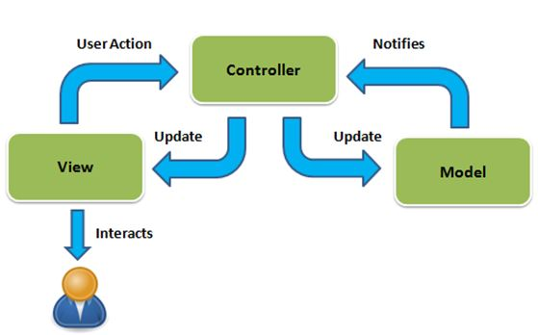

**Fig 1: System Diagram**

System Diagram show that how the system will work for the user and how to backend will react to that user input.

1. **Visual Studio:**

Visual Studio Code is a freeware source-code editor made by Microsoft for Windows, Linux and mac OS. Features include support for debugging, syntax highlighting, intelligent code completion, snippets, code refactoring, and embedded Git. Users can change the theme, keyboard shortcuts, preferences, and install extensions that add additional functionality.

Microsoft has released most of Visual Studio Code's source code on the microsoft/vscode (Code - OSS) repository of GitHub, under the permissive MIT License, while the releases by Microsoft are proprietary freeware.

In the Stack Overflow 2019 Developer Survey, Visual Studio Code was ranked the most popular developer environment tool, with 50.7% of 87,317 respondents reporting that they use it.

Visual Studio Code was first announced on April 29, 2015, by Microsoft at the 2015 Build conference. A Preview build was released shortly thereafter.

On November 18, 2015, Visual Studio Code was released under the MIT License, having its source code available on GitHub. Extension support was also announced. On April 14, 2016, Visual Studio Code graduated from the public preview stage and was released to the Web.

**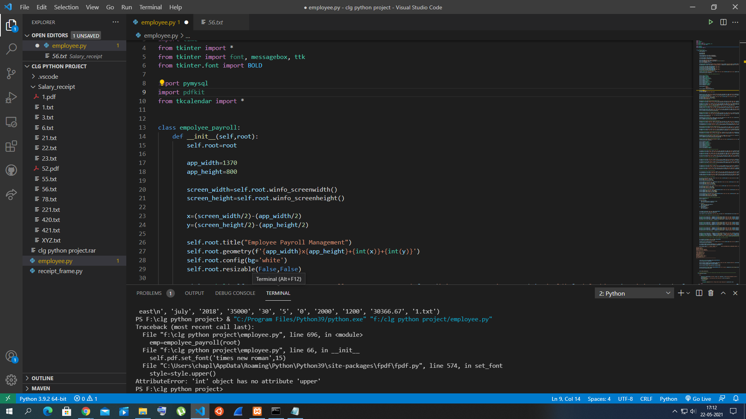**

**Fig 2: Visual Studio**

In our Project Visual Studio has mostly use for code writing as it is good for editing.

Out-of-the-box, Visual Studio Code includes basic support for most common programming languages. This basic support includes syntax highlighting, bracket matching, code folding, and configurable snippets. Visual Studio Code also ships with IntelliSense for JavaScript, Type Script, JSON, CSS, and HTML, as well as debugging support for Node.js. Support for additional languages can be provided by freely available extensions on the VS Code Marketplace.

1. **Xampp:**

XAMPP is a software distribution which provides the Apache web server, MySQL database (actually MariaDB), Php and Perl (as command-line executables and Apache modules) all in one package. It is available for Windows, MAC and Linux systems. No configuration is necessary to integrate Php with MySQL.

It is a great fit for this course and provides a relatively painless installation and way to manage the configuration changes. Also provided is PhpMyadmin which gives a GUI tool for managing your MySQL databases.

I would highly recommend installing this for Windows or MAC. It doesn't exclude you from other competing software installations, it just gives an easy way to get going. For Ubuntu Linux systems, I still would recommend installing Apache/MySQL/Php/PhpMyadmin through Ubuntu packages. It is used for Creating servers and storing the data of the employee in it.

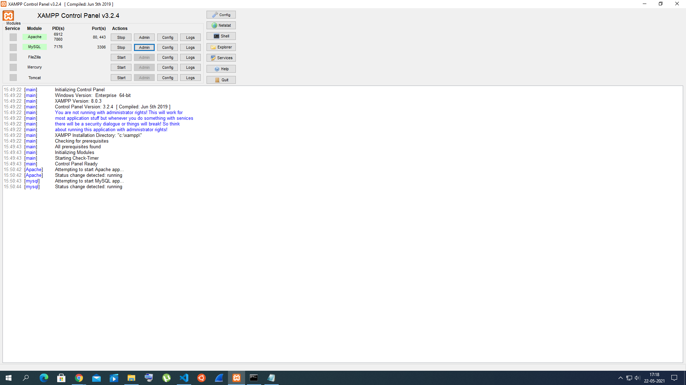

**Fig 3: Xampp**

Xampp is used for creating server for database and storing the data init.

Start both MySQL and Apache (unless you have an alternative Apache installation). I do not recommend messing with the Modules service column. When you start MySQL, you should see it running on port 3306. The Apache service gives you access to the Admin buttons next to the services.

**d) Tkinter:**

Tkinter is a Python binding to the Tk GUI toolkit. It is the standard Python interface to the Tk GUI toolkit, and is Python's de facto standard GUI. Tkinter is included with standard Linux, Microsoft Windows and Mac OS X installs of Python.

The name Tkinter comes from Tk interface.

As with most other modern Tk bindings, Tkinter is implemented as a Python wrapper around a complete Tcl interpreter embedded in the Python interpreter. Tkinter calls are translated into Tcl commands, which are fed to this embedded interpreter, thus making it possible to mix Python and Tcl in a single application.

There are several popular GUI library alternatives available, such as wxPython, PyQt, PySide, Pygame, Pyglet, and PyGTK.

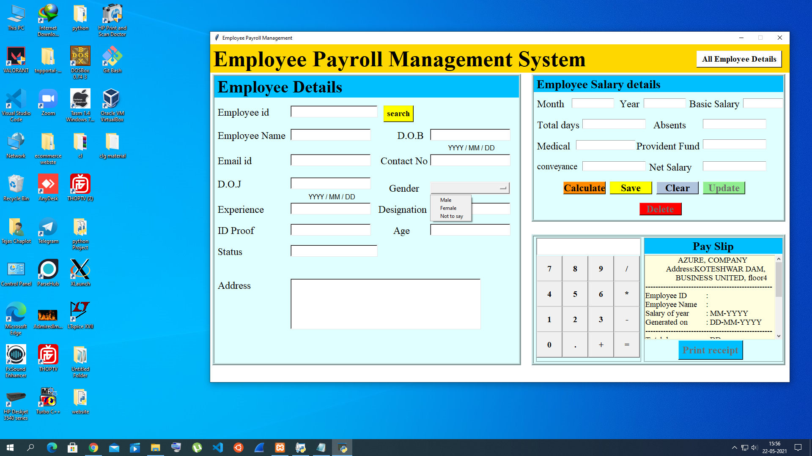

**Fig 4: Tkinter GUI**

Our main frame is all designed in tkinter.

**e) MySQL:**

A database is a separate application that stores a collection of data. Each database has one or more distinct APIs for creating, accessing, managing, searching and replicating the data it holds.

Other kinds of data stores can also be used, such as files on the file system or large hash tables in memory but data fetching and writing would not be so fast and easy with those types of systems.

Nowadays, we use relational database management systems (RDBMS) to store and manage huge volumes of data. This is called relational database because all the data is stored into different tables and relations are established using primary keys or other keys known as Foreign Keys.

we used MySQL database and Apache server to store the data of the employee

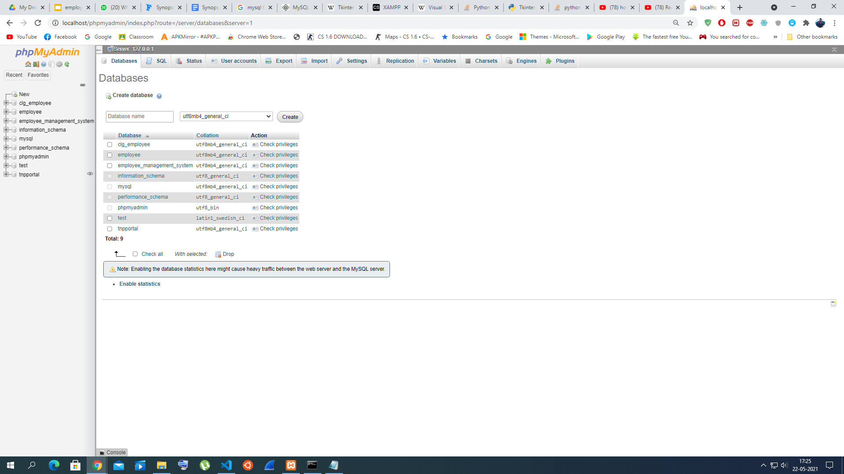

**Fig 5: MySQL Database**

All the data has been stored here.

Computers that install and run RDBMS software are called clients. Whenever they need to access data, they connect to the RDBMS server. That’s the “client-server” part.

MySQL is one of many RDBMS software options. RDBMS and MySQL are often thought to be the same because of MySQL’s popularity. A few big web applications like Facebook, Twitter, YouTube, Google, and Yahoo! all use MySQL for data storage purposes. Even though it was initially created for limited usage, it is now compatible with many important computing platforms like Linux, mac OS, Microsoft Windows, and Ubuntu.

**Input Data and Validation of Project:**

* All the fields are required in our project such as Employee-id, Employee name, Employee-phone number, Employee-email id and Employee-id proof.
* NO fields can acquire blank entries.
* It requires a unique employee id no two employee id can match while entering the data.
* If once data is stored it can only be updated it will not add the same data with the same employee id.
* All the calculation fields must be entered in Integer value except month fields (as it can be in word or digits).

**7. References**

**1.** [**https://codemy.com/intro-tkinter-python-gui-apps/**](https://codemy.com/intro-tkinter-python-gui-apps/)

**2.** [**https://www.geeksforgeeks.org/fundamentals-of-algorithms/**](https://www.geeksforgeeks.org/fundamentals-of-algorithms/)

**3.** [**https://youtube.com/channel/UCKJnF\_GhwvmXqtGh9LePXpg**](https://youtube.com/channel/UCKJnF_GhwvmXqtGh9LePXpg)

**4.** [**https://github.com/**](https://github.com/)

**5.** [**https://www.freeprojectz.com/**](https://www.freeprojectz.com/)

**6.** [**https://www.dhsinformatics.com/ieee-projects-bangalore/ieee-python-projects/**](https://www.dhsinformatics.com/ieee-projects-bangalore/ieee-python-projects/)

**7.** [**https://ieeexplore.ieee.org/document/1167275**](https://ieeexplore.ieee.org/document/1167275)

**8.** [**https://realpython.com/python-application-layouts/**](https://realpython.com/python-application-layouts/)